**Experiment No. 3.1**

**Student Name: Rishav Kumar UID: 22MCC20039**

**Branch: MCA - CCD Section/Group: MCD-1/ Grp A**

**Semester: IV Date of Performance: 10th Apr 24**

**Subject Name: CI/CD Pipelines Subject Code: 22CAP-781**

1. **Aim/Overview of the practical:**

a. Write a scripted pipeline for maven project.

b. Now, create users in Jenkins, give matrix-based permissions.

1. **Code for practical:**

a.)

1. Open a Java project.
2. Make a file named Jenkinsfile.
3. Enter followinf script to Jenkinsfile.

pipeline {

    agent any

    tools {

        maven 'mvn'

    }

    stages {

        stage("Fetching") {

            steps {

                git branch: "master",

                url: "https://github.com/Rishav518/java"

            }

        }

        stage("Compile") {

            steps {

                bat 'mvn compile'

            }

        }

        stage("Test"){

            steps{

                bat 'mvn test'

            }

        }

        stage("Package"){

            steps{

                bat 'mvn package'

            }

        }

        stage("Verify"){

            steps{

                bat 'mvn verify'

            }

        }

        stage("Install"){

            steps{

                bat 'mvn install'

            }

        }

    }

}

b.)

1. Open Jenkins on localhost.
2. Go to Manage Jenkins.
3. Go to Configure Global Security.
4. Select Jenkins own User Database.
5. Tick the checkbox “Allow Users to Sign Up”.

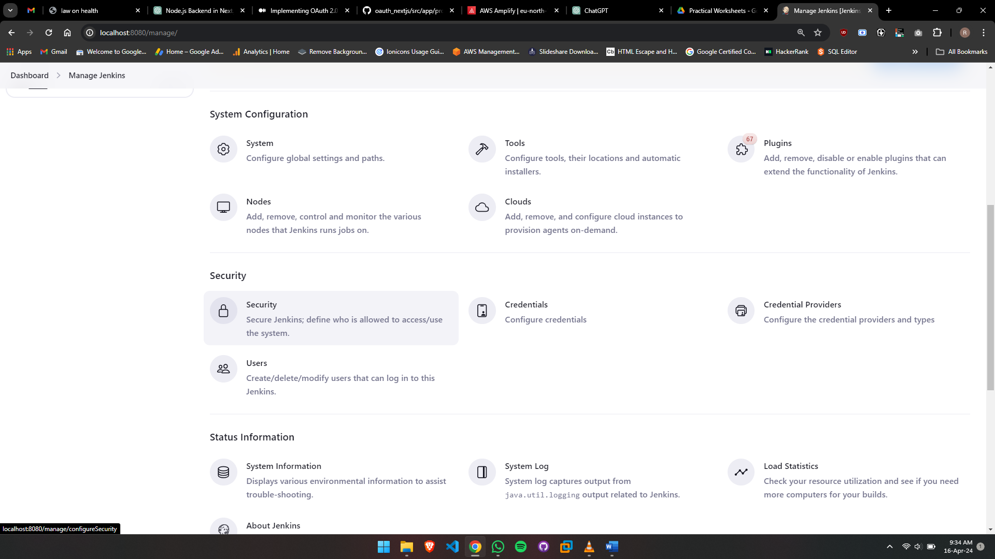

1. Select Matrix-based security.
2. Select the button “Add user or group”.
3. Enter the user's user id and select “Administer” in the table.

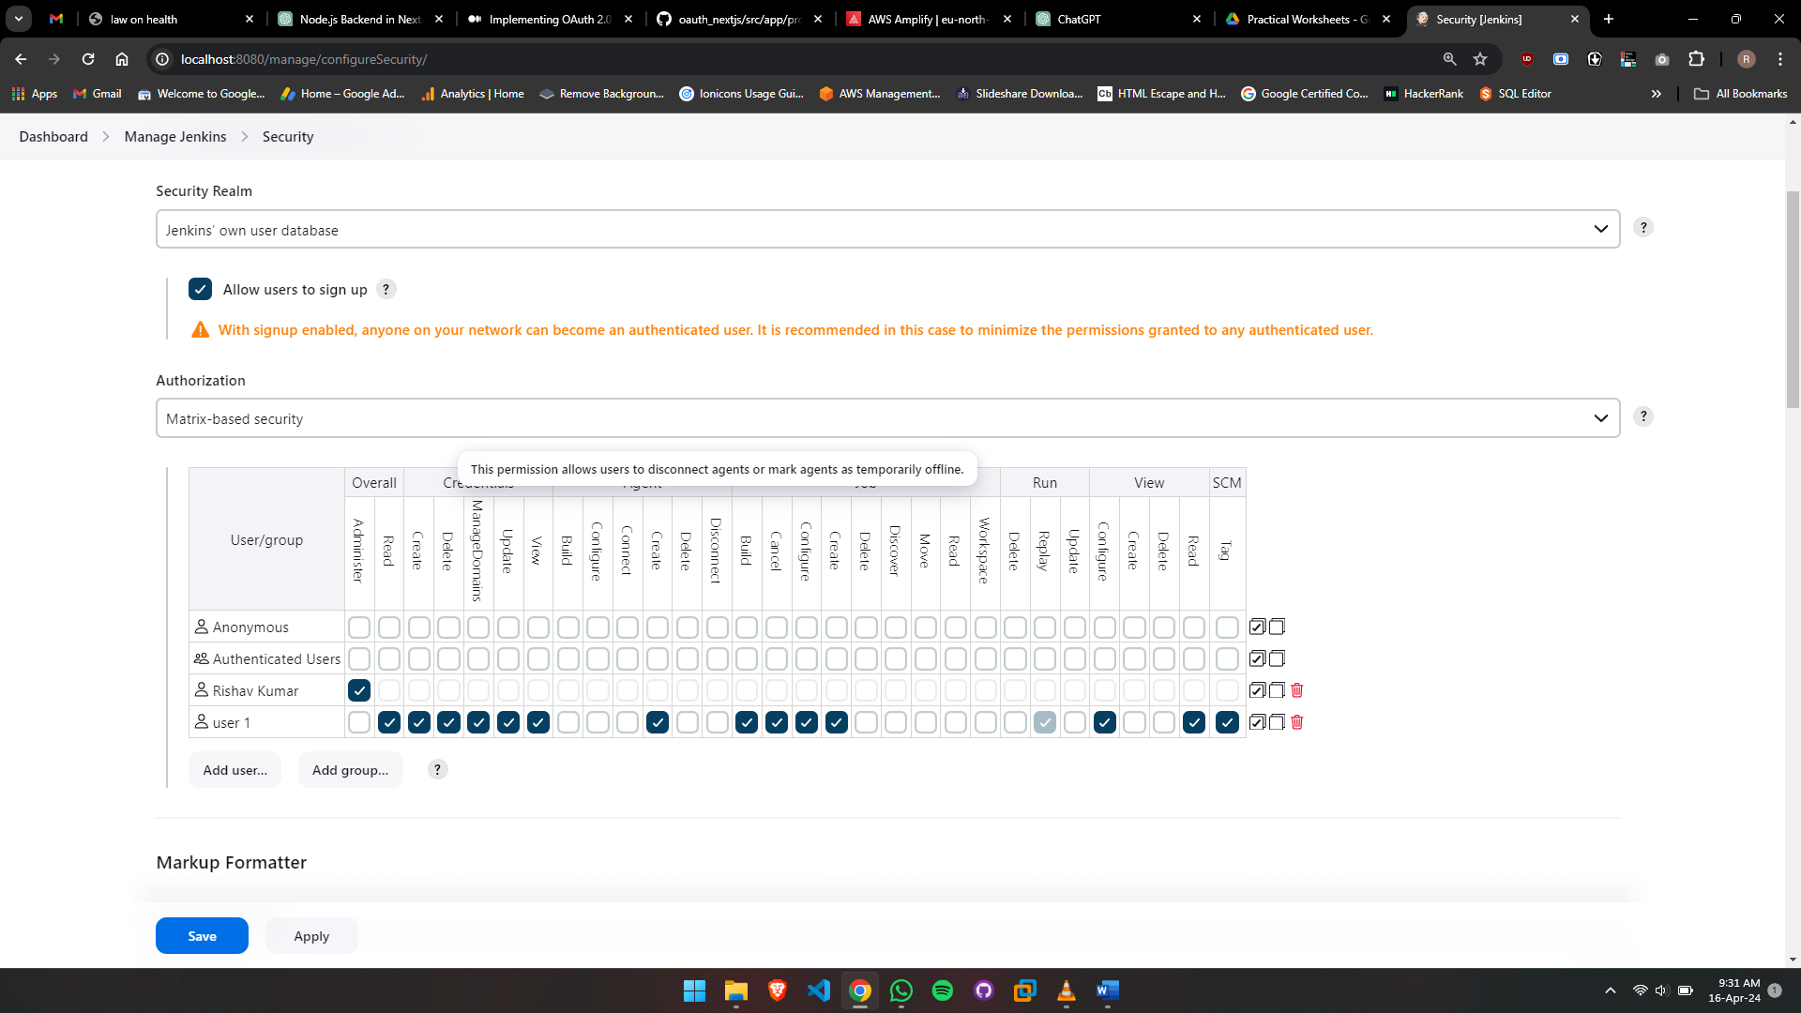

1. Click on the "Ok" button.